Practical - 11
Practical Title: 11: Student Management CRUD with Search and Filter

Problem Definition: Create a student management module to add, view, edit, delete, search and

filter student records. All database operations must use MYSQLi

statements and clear success/failure messages.

Theory

1. Are SELECT, INSERT, UPDATE, and DELETE operations working?
ANSWER: Yes, all four CRUD operations are working correctly. INSERT adds new student records, SELECT displays student records, UPDATE modifies existing records, and DELETE removes records from the database. Success and failure messages are displayed to the user.

2. Is search by name/email/course implemented?
ANSWER: Yes, the search functionality allows users to find student records using their name, email, or course. It makes retrieving specific student information easier and faster.

3. Are delete operations confirmed before execution?
ANSWER: Yes, a confirmation message is displayed before deleting a student record. This helps prevent accidental deletion of important data.

Implementation/ Output/Result:

Evidence of Work (Screenshots):

Database created.
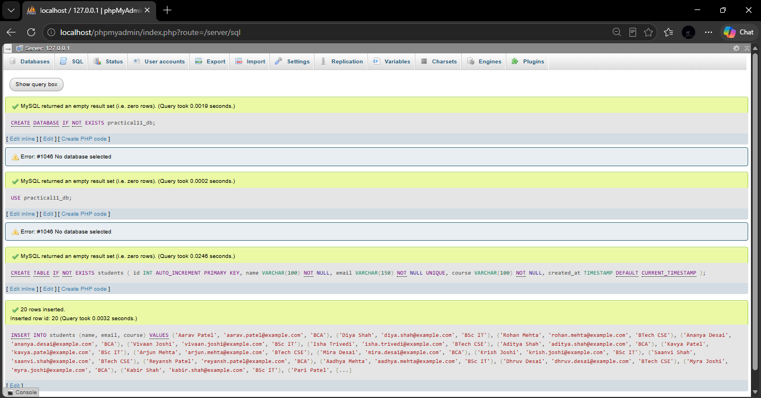

Student add:
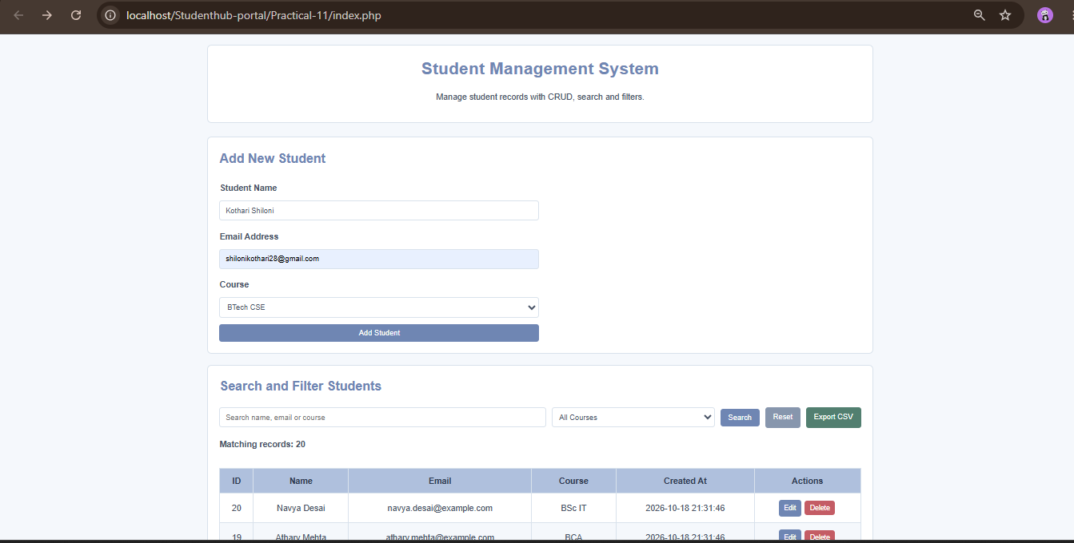
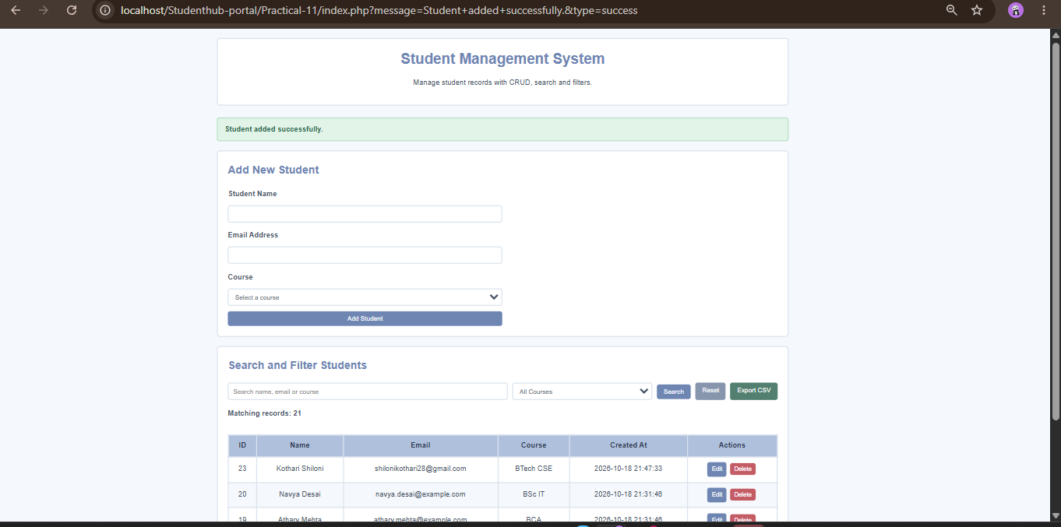

Edit the student:
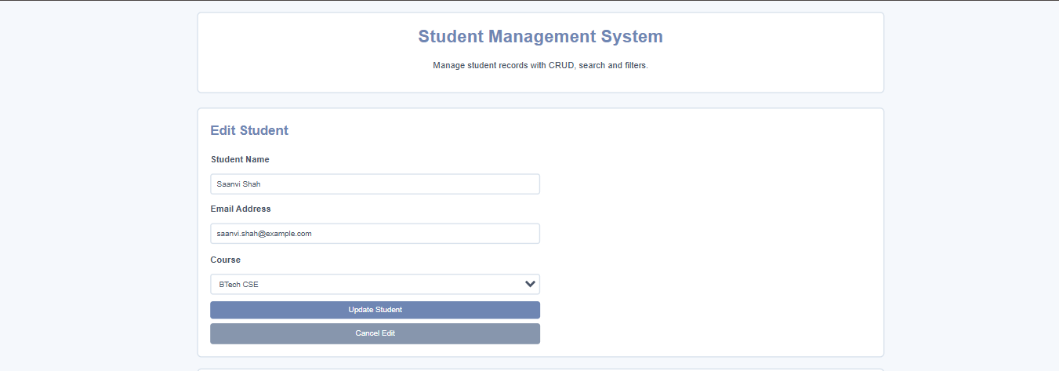


Searching of a student:

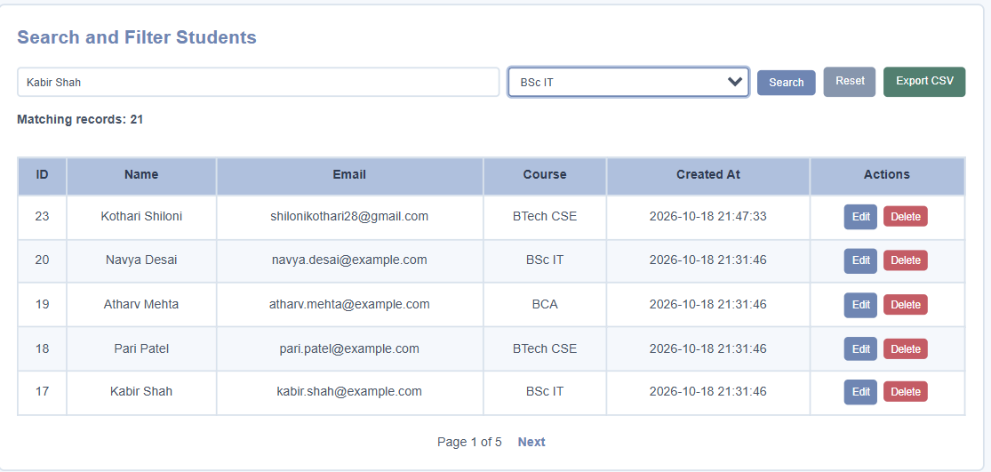

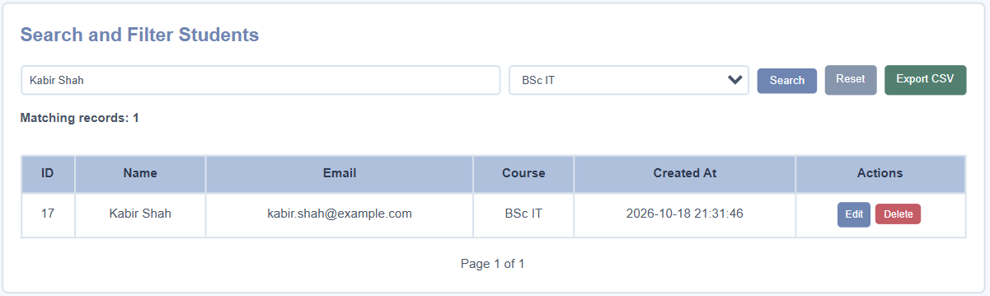

Deletion of a student:
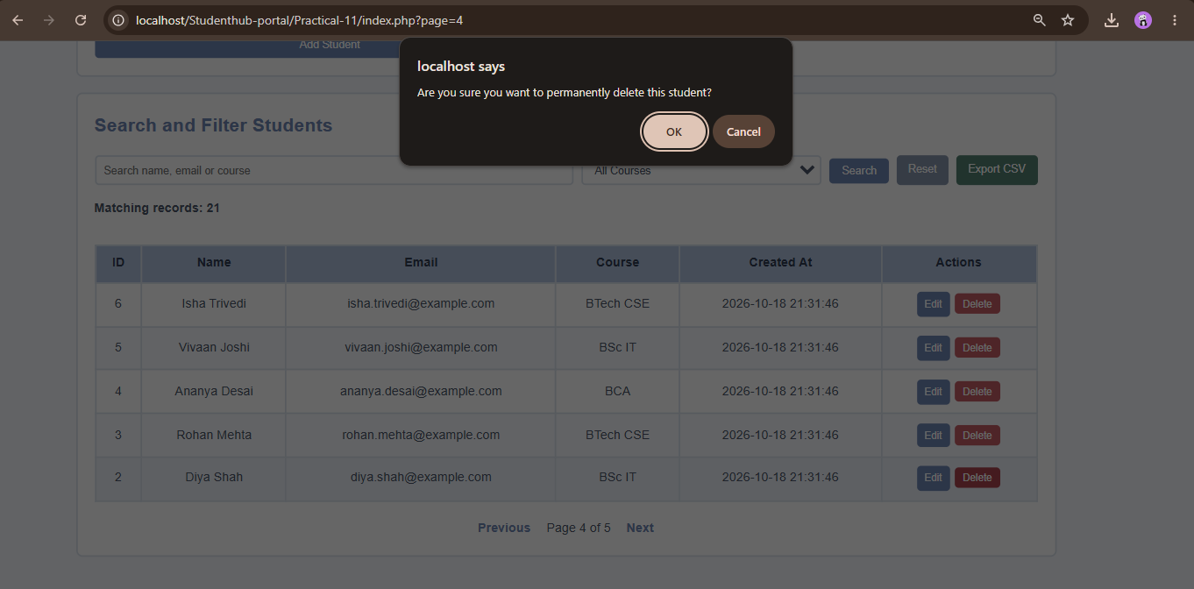


Database in MYSQL: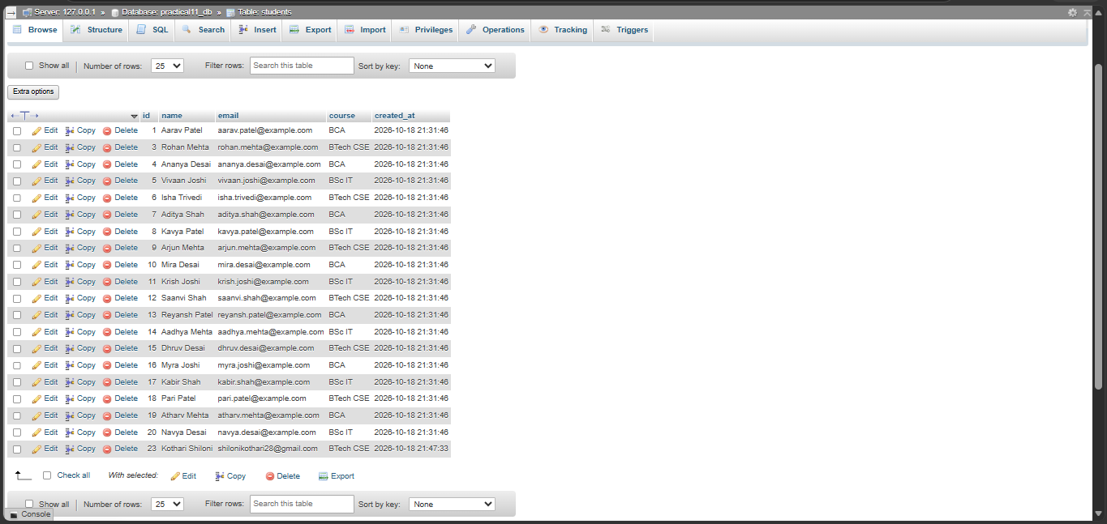
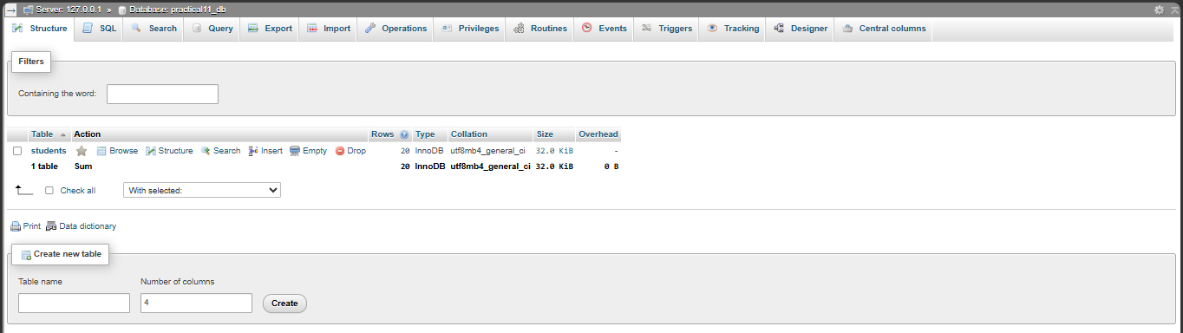

GitHub Repository Link:

https://github.com/shiloni28/WDF.git

E.Challenges Faced:

- Database connectivity: Establishing a proper connection between PHP and the MySQL database.
- CRUD operations: Implementing all four operations correctly and ensuring that changes are reflected in the database.
- Search and filtering: Writing SQL queries to search student records by name, email, or course.
- User interface feedback: Displaying appropriate success, failure, and delete-confirmation messages.
- Record management: Ensuring that the correct student record is updated or deleted without affecting other records.
- Also to see that the data is secured after doing CRUD operations.

F.Learning Outcomes:

- Learned how to implement CRUD operations using PHP and MySQL.
- Understood how to insert, retrieve, update, and delete student records from a database.
- Learned to implement search and filter functionality using student name, email, and course.
- Understood the importance of prepared statements for preventing SQL injection.
- Gained practical experience in developing a data-driven student management module.

Faculty Remarks:

